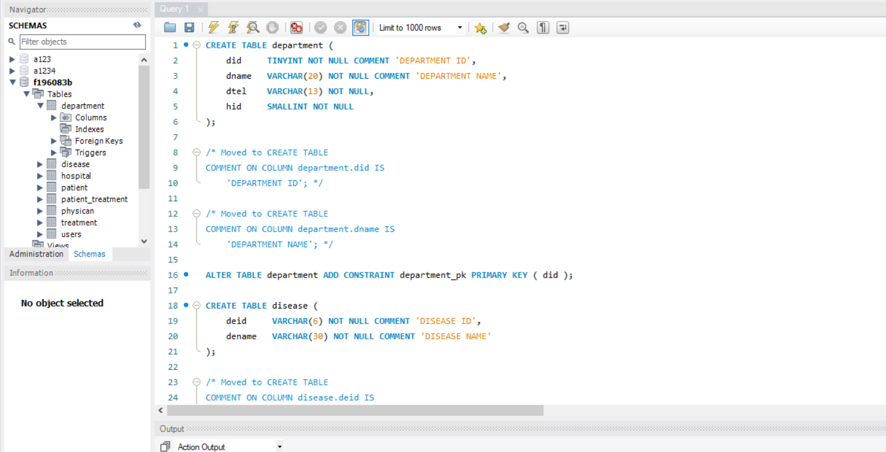

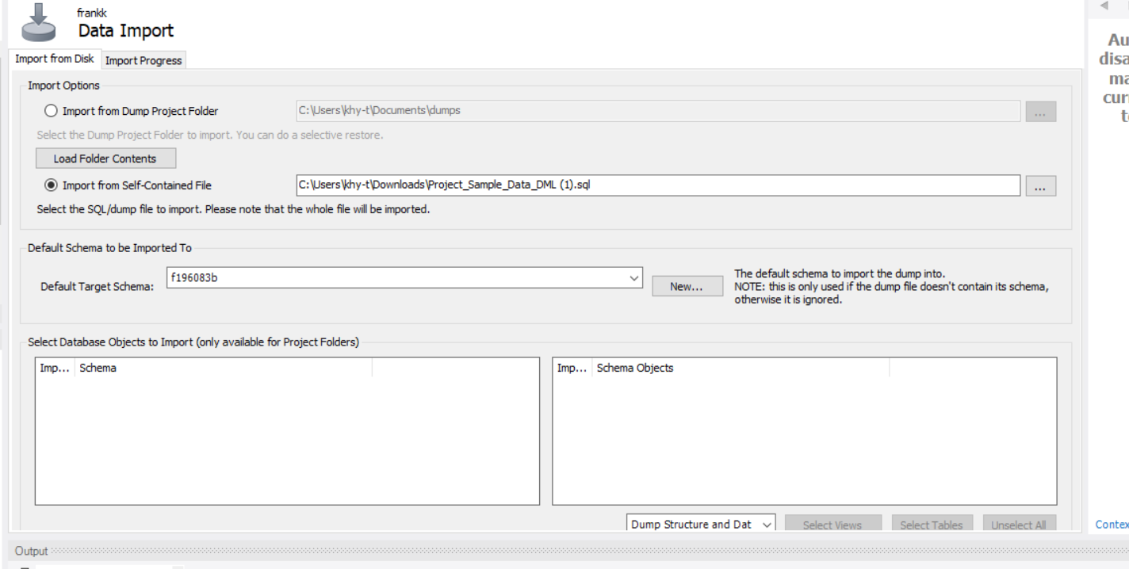

Second step: using php, xampp and mysql workbench to finish the web application and javascript to beautify our web.

Create connection between php and database.

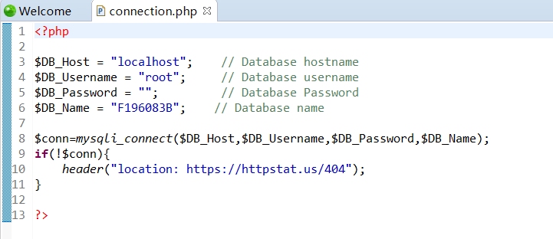

Web application:

3 tables: hospital, physician and patient. All the data can be shown on the web.

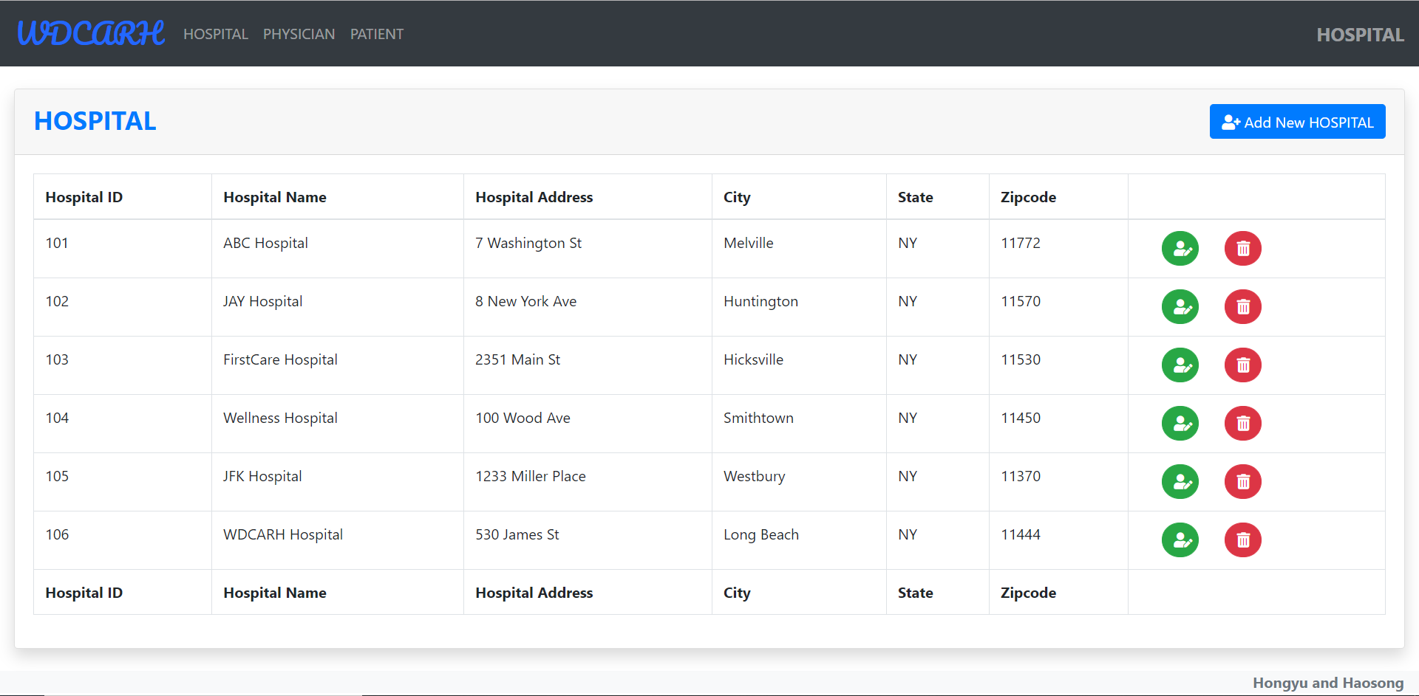

When we click the green button, we can update the data. The primary key will not be changed.

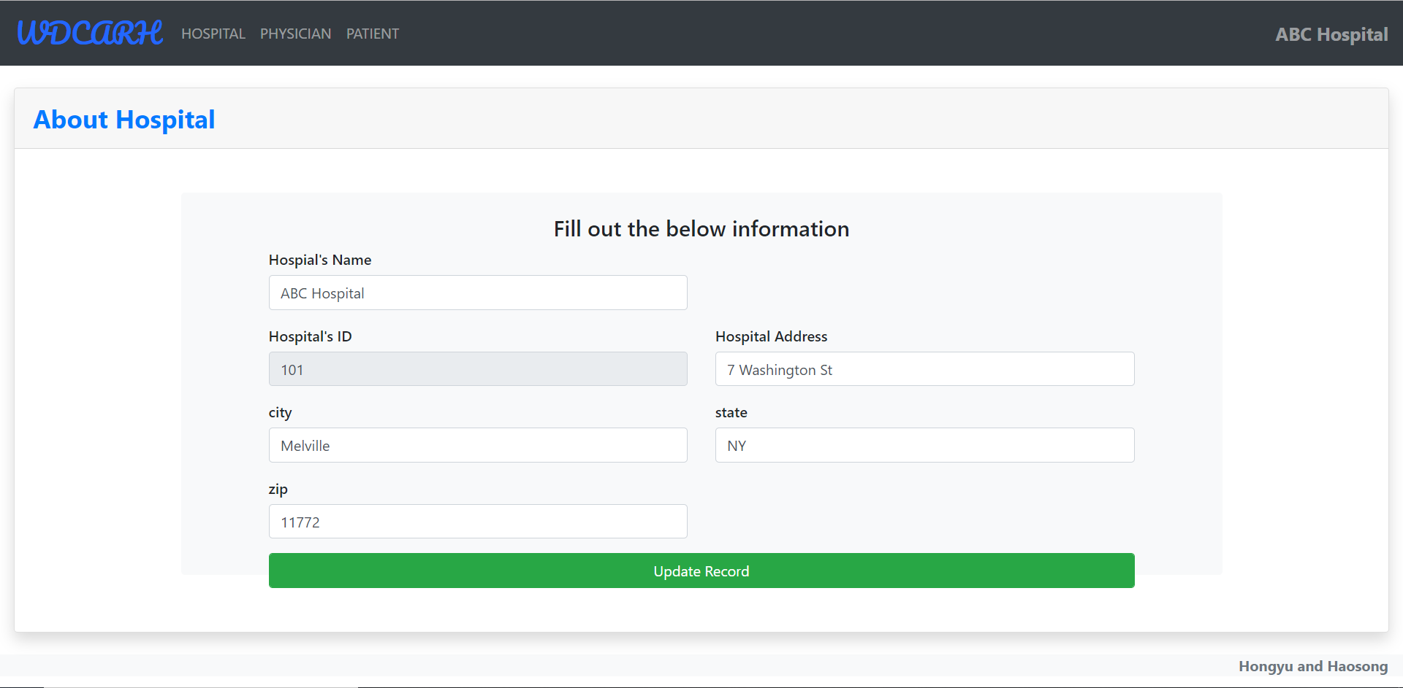

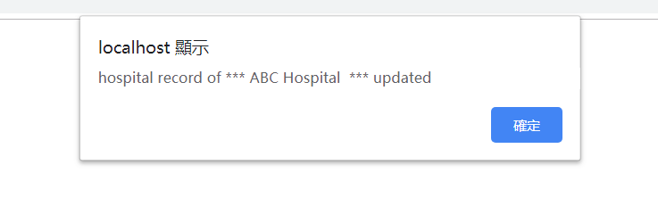

When we click update record, we can see we success update. The zip code change from 11772 to 11773.

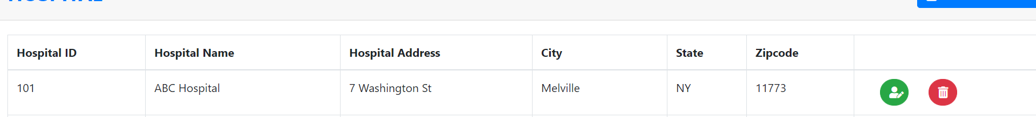

If we enter a wrong data such as more digit than the Specified length, it will tell you that you could not update the data.

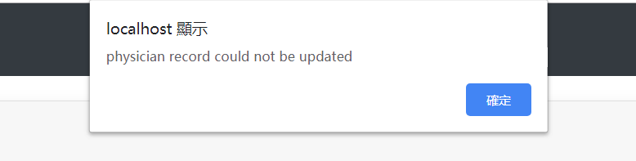

When we click the ‘add new hospital’ button, we can insert new data into the database.

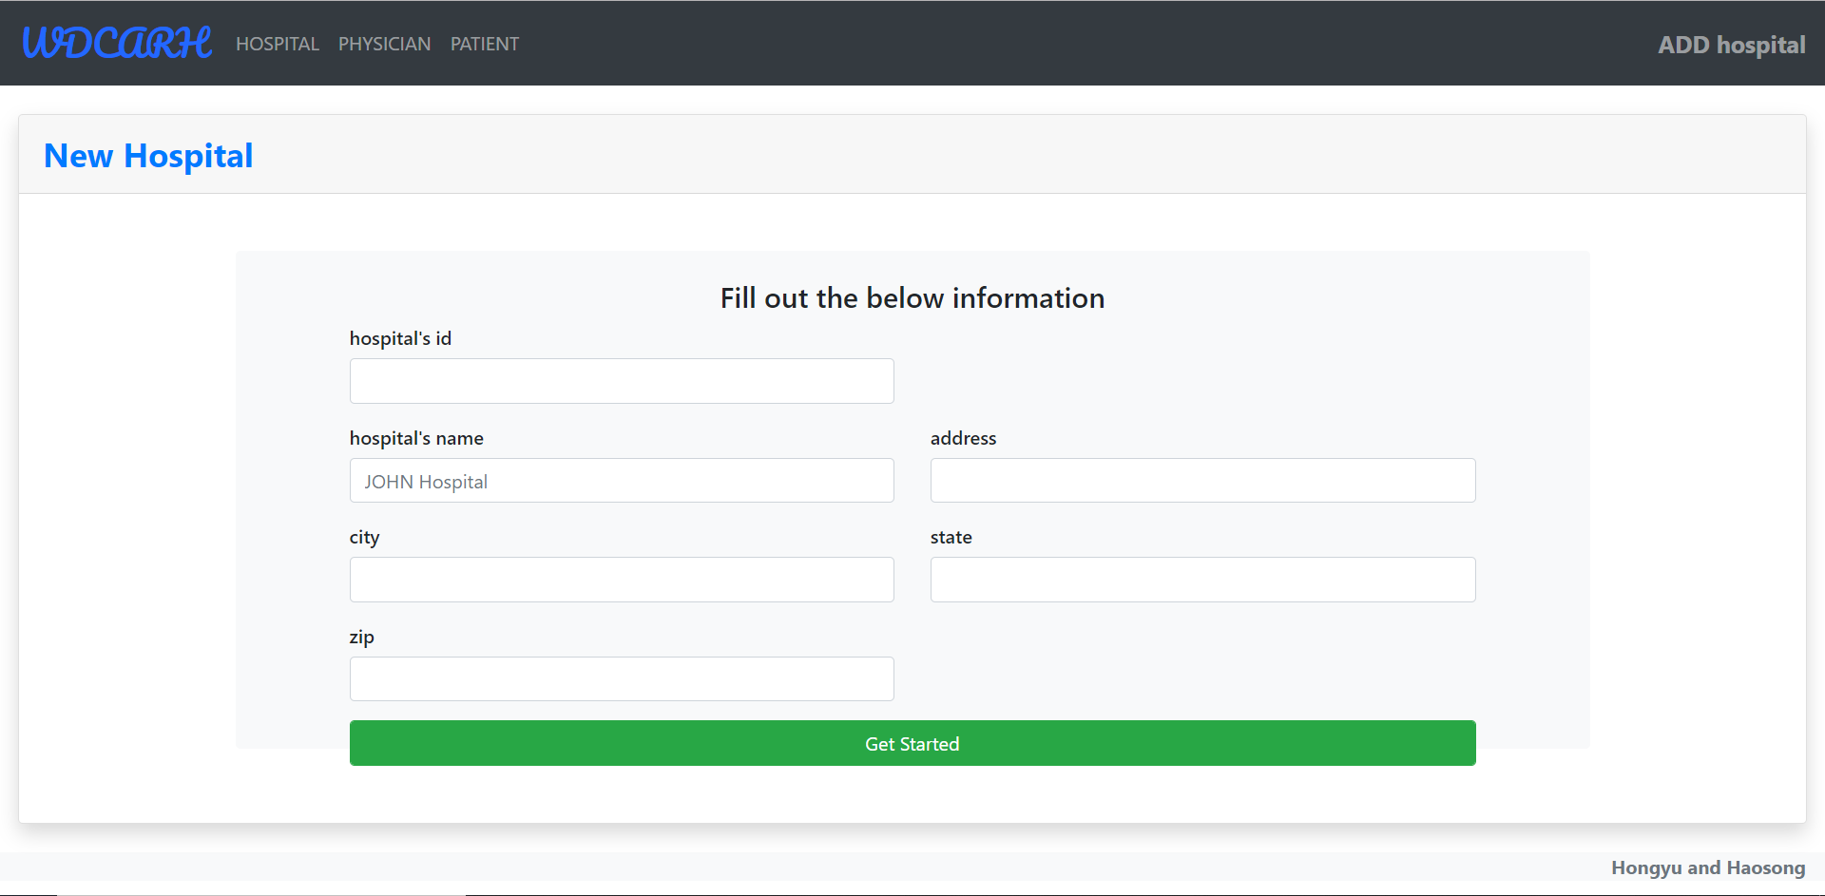

We can see the new data in the table. Also, if you enter a wrong data, you will be remaindered you can not insert the data.

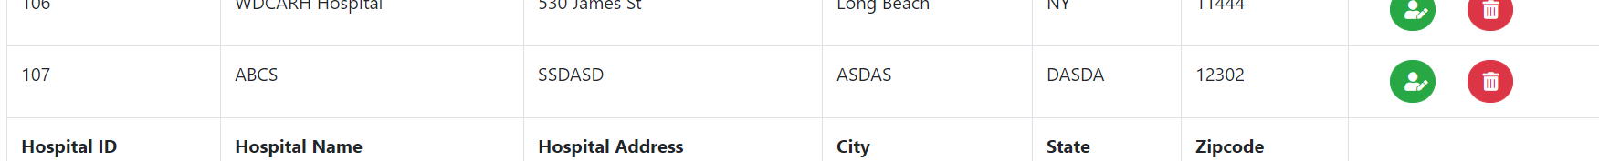

When we click the red button, we can delete the data. The data we inserted has been deleted.

